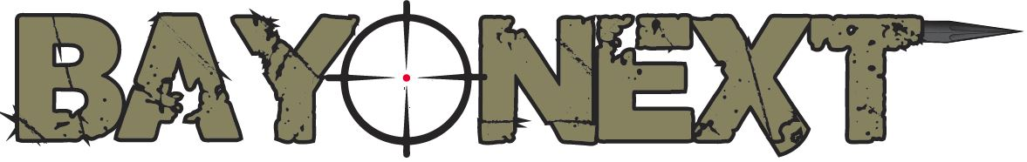

Operating Instructions v1.0
Read this document thoroughly prior to assembly!

Thank you for purchasing Bayonext, the world’s only hand guard / rail mountable automatic bayonet! Bayonext is proudly made in the USA in Claxton, GA. We appreciate your trust in our product, and we look forward to providing you with great service and additional products in the near future! You can contact us anytime via Facebook or emailing us at contact@bayonext.com.

This document may also be downloaded from our website: www.bayonext.com

WARNING:
- When using your Bayonext while it is mounted to a firearm, ALWAYS follow basic firearm safety!
- You should NEVER deploy Bayonext with any part of your or someone else’s body in the path of the spike.
- You should NEVER attempt to retract the spike back into the retracted (closed) position with your hand or any part of your body.
- You should NEVER attempt to disassemble your Bayonext with the spike in the retracted (closed) position. Always deploy the spike prior to disassembly in order to release as much spring tension as possible.

Assembly:
Your Bayonext ships disassembled for safety reasons. Assemble using the following instructions prior to use. Please note that the back of the spike is hollowed out. During assembly the spring must be inserted into the spike for proper use.
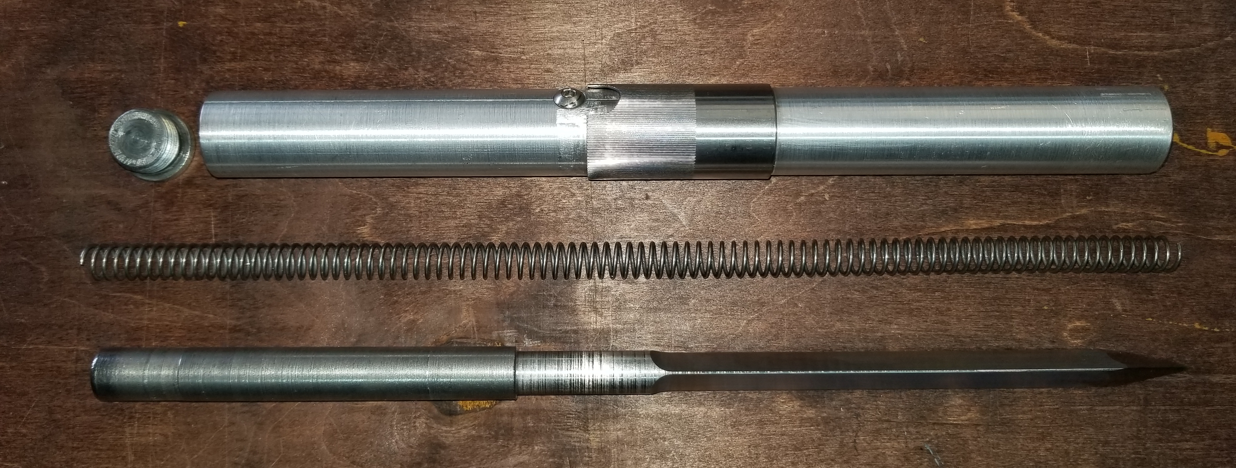
- 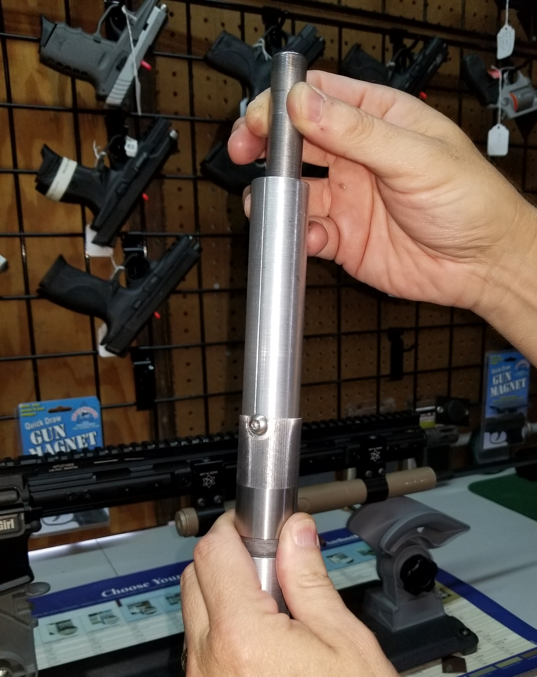Hold the housing vertically with the threaded end up (See figure 1). The threads should be visible at the top. IMPORTANT: Ensure that the hand holding the housing does not cover the hole in the bottom! Insert the tip of the spike into the housing of your Bayonext and let it fall until the tip protrudes out the bottom. You should hear the spike bottom out inside the housing.

- With your Bayonext still held vertically line up the notch in the firing collar with the safety screw and pull the collar upward. This will release the spike, and it will fall until it is in the fully deployed position. Again, you should hear the spike bottom out inside the housing. Figure 1
Release the collar, and it will automatically spring back into the locked position.

- Next turn the assembly so that you are holding it horizontally (see figure 2) with the spike locked in the open position. Insert the deployment spring into the rear of the housing (the spring inserts into the hollow end of the spike which should be fully deployed). Approximately 2” of the deployment spring should still be visible at this point.

- Take the retaining/maintenance plug provided and carefully push it against the protruding end of the spring until the spring is completely enclosed. The plug comes in contact with the threads on the inside of the housing. Rotate the plug clockwise until it is hand tight. Then use a 5/16” allen wrench (not provided) to tighten.

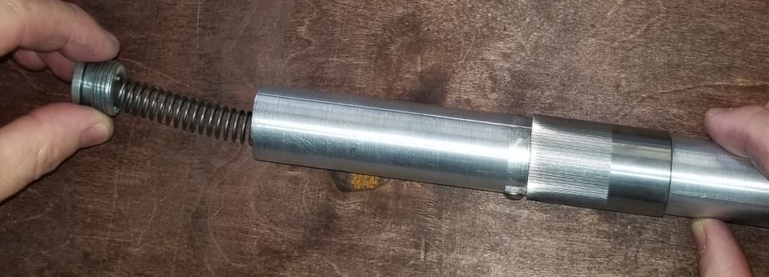

Figure 2
Disassemble in reverse order
IMPORTANT: The deployment spring is under a high level of tension when your Bayonext is in the retracted or closed position. Make sure that you fully deploy the spike prior to removing the retaining/maintenance plug.

Maintenance:
Your Bayonext should stay lightly lubricated. Periodically or after heavy use, you should disassemble your Bayonext and check the spring and spike for dust or dirt. If possible use compressed air to push dirt or grime out of the housing. When clean, lightly oil or grease the spike and spring with high quality lubricant and re-assemble.

Mounting:
The outside diameter of your Bayonext measures 1”. It was designed so that you can mount Bayonext to any firearm that mates with any industry standard 1” flashlight mount. We do not recommend using polymer mounts for strength purposes. Make sure that you tighten the mounting screws per the mount’s instructions. Your Bayonext propels forward extremely fast. If the mounts holding your Bayonext aren’t secure it may slip forward as it is being deployed.

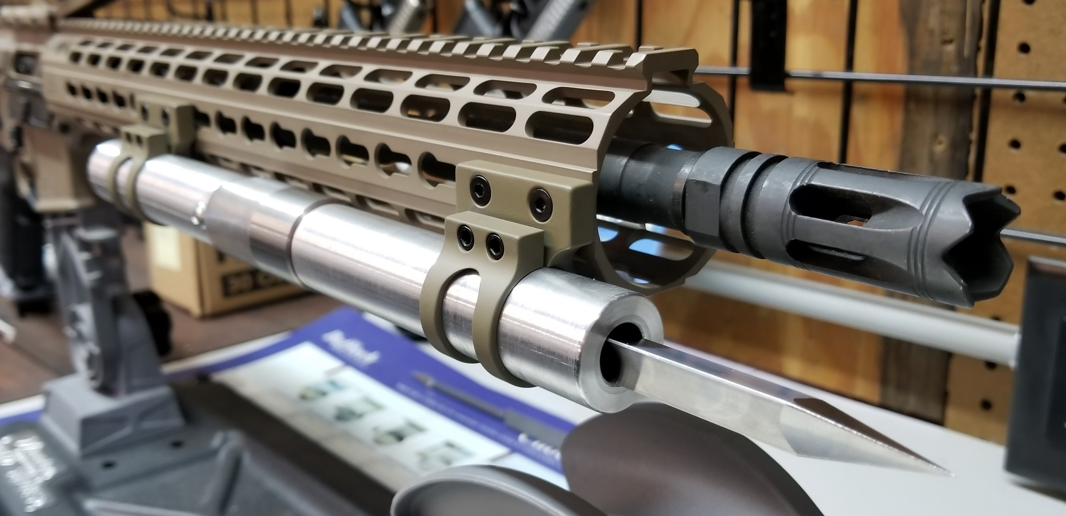

In the example above, this Bayonext is mounted to a 15” free float hand guard using 1” Keymod mounts. Note that the front and rear mounts are positioned away from the deployment collar so they will not interfere with the operator’s hand while deploying the spike. You can mount Bayonext at any position on your hand guard that you like, but you must position your mounts in such a way that they will not interfere with the travel of the deployment collar. We highly recommend that you mount your Bayonext so that the tip of the spike is at least 0.25” forward of the face of your muzzle device or barrel (if no muzzle device is attached). The purpose of this is so that your barrel or muzzle device doesn’t interfere with the spike fully locking when you are moving it to its retracted (closed) position.

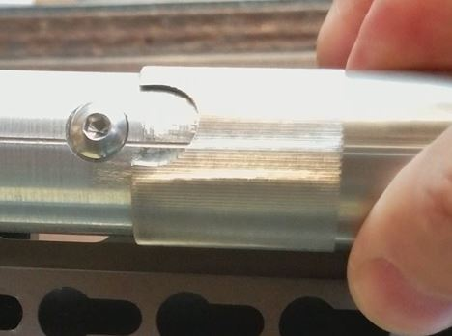Operation:
To deploy your Bayonext, first point it in a safe and clear direction. Rotate the deployment collar so that the notch in the collar lines up with the safety screw (see figure 3). Pull the collar to the rear until the spike deploys. Note: Do not hold the collar back. It is under spring tension, so simply pull it toward the rear and let go when the spike begins to deploy. The collar will automatically propel forward to lock the spike in the deployed (open) position. Figure 3

To retract your Bayonext pull the collar to the rear. Push the tip of the spike against any hard or semi-hard surface such as a post, tree trunk, wall, etc. Once the spike begins to move, release the collar and continue retracting until the spike is fully retracted and the collar snaps back into the locked position. Rotate the collar approximately 90 degrees to render the spike safe.

WARNING: When retracting (closing) the spike do not push the tip against any delicate or smooth/finished surface such as a table top or you will permanently damage the surface. Also, you should NEVER attempt to retract (close) the spike with your hand or any part of your body. Serious injury can occur.

You can view a short video demonstrating deploying and retracting Bayonext on our Facebook page at www.facebook.com/bayonext.
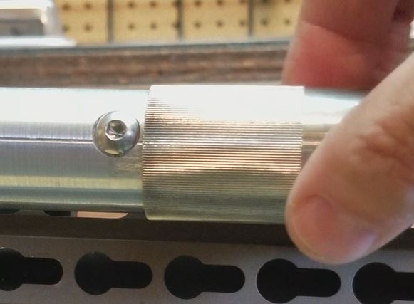
When your Bayonext is not in use, cover the tip of the spike with the provided rubber cap to prevent injury or damage to nearby objects. You should also rotate the collar so that the notch in the collar does not line up with the safety screw which will prevent the collar from releasing the spike (see figure 4).

Figure 4

